Introduction Outline and Preliminary Analysis

**Introduction**

* *Background Info*
  + Endocrine disrupting chemicals:
    - Endocrine disrupting chemicals (ECDs) are substances or mixtures of substances that often mimic or interfere with the body’s hormones and endocrine system (Jung et al, 2012). Variations of endocrine disrupting chemicals can be found ubiquitously in everyday products, including plastic bottles, flame retardants, food, toys, cosmetics and pesticides.
    - BPA: Bisphenol A, is an EDC that is used to make polycarbonate plastics and epoxy resins, which are found in many plastic products including food storage containers.
    - BPS/BPF: Bisphenol S and Bisphenol F found in baby bottles, personal care products and thermal receipts, and many other daily use products. It was devised to serve as a replacement chemical for BPA and was introduced when concern was raised about possible health effects of that plastic compound. Though studies have found human BPS exposure is likely low, it is widespread and has increased over the past 10 years, the authors note. As with BPA, there is evidence that BPS is an endocrine disruptor.
    - As part of the efforts to phase out BPA, new congeners of the plasticizer started to be widely used in daily products. However, there is no clear evidence of the effects of these new versions in the onset of endocrine system effects, specifically effects on thyroid function.
* *Thyroid problems*
  + Clinical significance
    - Thyroid hormone/homeostasis is involved with proper growth, development, and metabolism.
    - Diseases/problems associated with thyroid issues
      * Hypothyroidism → disease examples/symptoms
      * Hyperthyroidism → disease examples/symptoms
    - Summary sentence answering: Why is thyroid hormone important for maintaining health
  + Background physiology
    - The central regulation of the thyroid and associated hormones are through the body’s Hypothalamus-Pituitary-Thyroid Axis. Homeostasis is maintained via a negative feedback loop that tightly regulates hormone levels. (could explain this further, or just show diagram? The main hormones released from the thyroid gland in order of abundance are Thyroxine (T4) and triiodothyronine (T3). T4 is an inactive form that is converted to the active form, T3, in target tissues for intracellular use or to be put back in circulation. T3 acts on target tissues such as the brain, liver, pancreas and fat cells to increase basal metabolic rate, heart rate, cardiac output and stimulate glucose production, energy expenditure, lipolysis. Thyroid hormones also play a role in many other signaling pathways related to metabolism, growth, and development.
  + Sources to cite: [Thyroid Physiology](https://journals.physiology.org/doi/full/10.1152/physrev.00030.2013), [Thyroid Physiology 2](https://journals.physiology.org/doi/full/10.1152/physrev.2001.81.3.1097)
    - 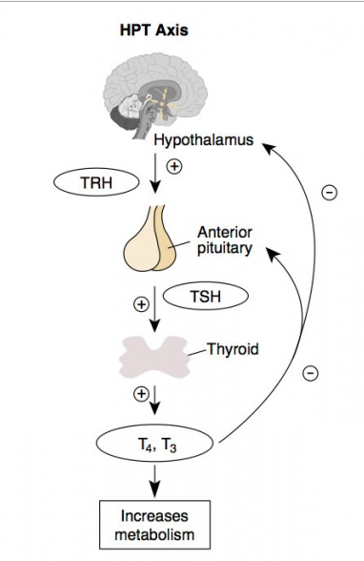
    - Image Citation: (Text book) Alberts, Bruce; Johnson, Alexander; Lewis, Julian; Raff, Martin; Roberts, Keith; Walter, Peter New York and London: Garland Science; c2002

**Motivations/Why is Project Important/How is this contributing to existing body of research?**

* BPA is associated with thyroid dysregulation → this widely shown
  + Makes sense that they are related (explain biologic plausibility)
    - Thinks it affects the HPT axis
    - Maybe talk a little about this/other proposed mechanism
  + Sources to cite: [Bisphenols and Thyroid Review](https://www.ncbi.nlm.nih.gov/pubmed/31884733)
* BPS and BPF are new and being used more now to replace BPA since it has been shown to be toxic (associated with thyroid dysregulation among other things)
  + Have similar structures, have not been tested with thyroid
  + Fair to assume might have similar effects
  + Similar(?) exposure, Similarly associated with obesity
    - Sources to cite: [NHANES BPA BPS BPF Obesity](https://www.ncbi.nlm.nih.gov/pubmed/31528831), [NHANES BPA, BPS, BPF](https://www.ncbi.nlm.nih.gov/pmc/articles/PMC6028148/)
* Mixtures
  + Assessing human exposure to mixtures of chemicals is becoming more commonplace with new methodological approaches that have been developed for this purpose. It is important to analyze the effects of exposure to chemical mixtures in addition to looking at chemicals individually, as models looking at exposure to mixtures are better approximation of real life exposures. On a day to day basis, we are not exposed to one chemical at a time, but rather are exposed to myriad chemicals throughout each day. Methods for studying exposure to chemical mixtures are relatively new, and to our knowledge, there have not been many studies to analyze co-exposure to Bisphenols and even fewer that compare associations between mixtures and outcomes with those of individual bisphenols.
  + Sources to cite: [Bisphenol Mixtures Study](https://www.ncbi.nlm.nih.gov/pmc/articles/PMC6321295/pdf/molecules-23-03226.pdf)

**Hypotheses**

* Confirming other researcher’s findings in our dataset: Exposure to bisphenol A, measured in urine concentrations, is associated with increased prevalence of l self-reported thyroid dysfunction.
* Exposure to Bisphenol F and Bisphenol S, assessed individually, is similarly associated with increased prevalence of self-reported thyroid dysfunction.
* Exposure to multiple synthetic organic chemicals (mixtures) is associated with increased prevalence of self-reported thyroid dysfunction.

**Exploratory Analyses**

* Missingness
  + From total NHANES samples (2011-12)
* Distributions
  + Exposures:
    - BPA
    - BPS
    - BPF
  + Outcome:
    - Thyroid self-report (current yes/no)
* Scatterplot with predicted values
  + Boxplots
* LOD
  + How many below?

*Missingness*

Total NHANES sample 2013-14, 2015-16 20,146

Restrict to 20 and older 11,488 (-8,658)

Restrict to those with urinary BPA 3,505 (-7,983)

Restrict to those with urinary BPF/S 3,502 (-3)

Final sample **3,502**

For current covariates of interest

joined %>%

drop_na(thyroid_problem) %>% ## n = 11,488 (8,658 under age 20 - constraint of thyroid Q)

drop_na(year) %>% ## n = "

drop_na(id) %>% ## n = "

drop_na(bpa_u) %>% ## n = 3,505 (7,983 missing info on BPA)

drop_na(bpa_u_det) %>% ## n = "

drop_na(bpf_u) %>% ## n = 3,502 (3 missing info on BPF)

drop_na(bpf_u_det) %>% ## n = "

drop_na(bps_u) %>% ## n = "

drop_na(bps_u_det) %>% ## n = "

drop_na(thyroid_problem) %>% ## n = "

#drop_na(thyroid_current) %>% ## don't want to drop NAs on this - responded NA if have never had thyroid issue

drop_na(sex) %>% ## n = "

drop_na(age) %>% ## n = "

drop_na(race) %>% ## n = "

*Distributions*

Exposures

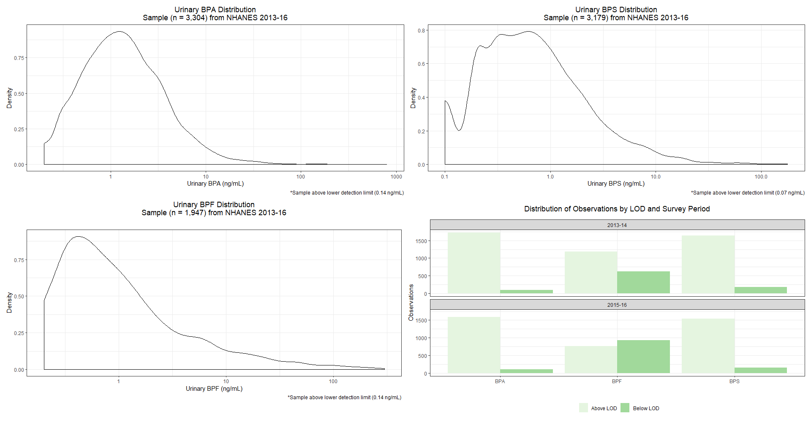

Outcome

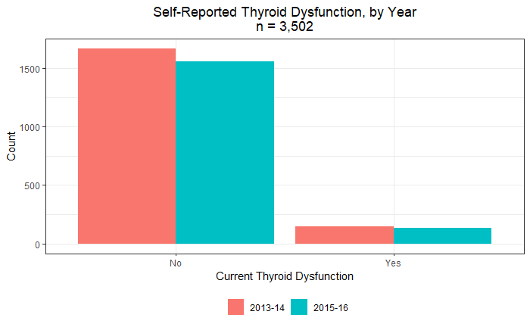

*Predicted values*

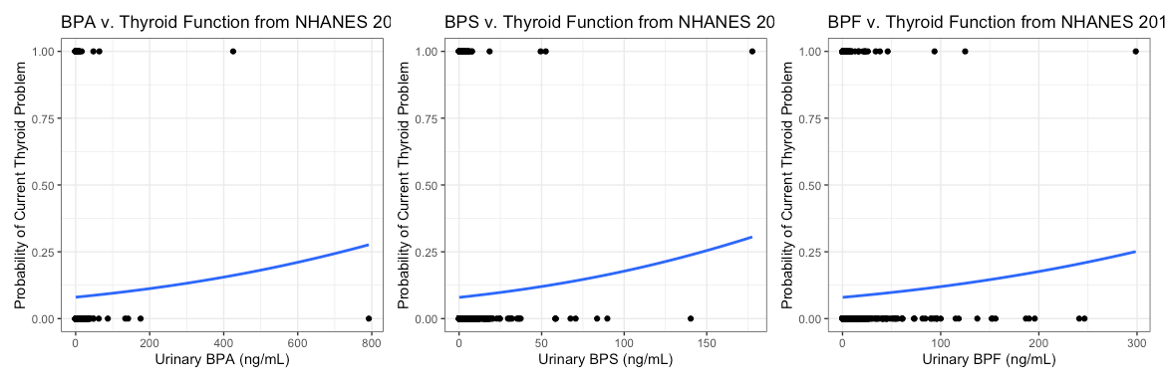

*Limit of detection counts:*

|  |  |  |  |
| --- | --- | --- | --- |
|  | *BPA* | *BPF* | *BPS* |
| *# of obs under LOD* | *198* | *323* | *1555* |

References:

1. Jung H, Hong Y, Lee D, Pang K, Kim Y. The association between some endocrine disruptors in human plasma and the occurrence of congenital hypothyroidism. *Environmental Toxicology and Pharmacology*. 2013;35(2):278-283. doi:[10.1016/j.etap.2013.01.002](https://doi.org/10.1016/j.etap.2013.01.002)